reg no: 192111496

Name: M KRISHNA VAMSHIDHAR REDDY

**CODE:CSA1366**

**EXPERIMENT: 5**

**AIM:** To design a PDA for the input aabbbbc (L=a^nb^2n).

**PROCEDURE:**

1. Select FOUR states and consider one as initial and another as final state.
2. Join the states using edges with directioons
3. Select the edges as PUSH,PULL and POP as a or b or c.
4. start the simulation and give the input.

**DESIGN AND OUTPUT:**

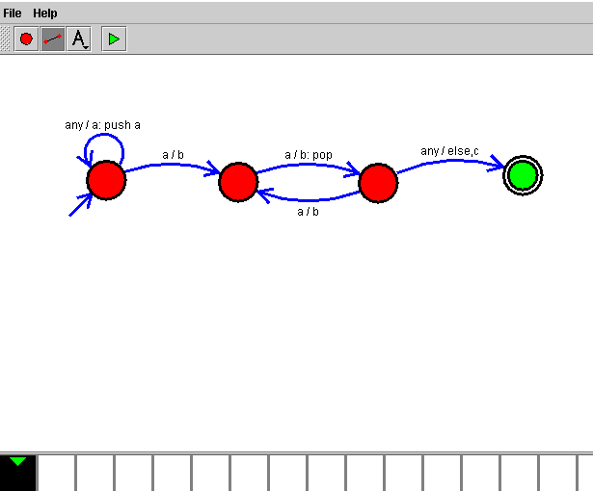

**RESULT:**

Therefore the designing of PDA for the given input has been successfully created and stimulated.